LOCALIZATION SEMINAR
EAS 564 and ENV 484 – Wednesdays 5:30-8:00 pm – Fall 2026
INSTRUCTORS
Raymond De Young rdeyoung@umich.edu, G168 Dana Building
Thomas Princen tprincen@umich.edu, 2506 Dana Building
READINGS
- De Young, R. and T. Princen (2012) The Localization Reader: Adapting to the Coming Downshift. Cambridge, MA: The MIT Press.
- Other readings are available on UM Canvas website under Files.
SCHEDULE
Theme | Date | Topic |  | Mini-lecture
Blame no one: | Summer |  | Biophysical and institutional premise
Blame no one: | 9/2 |  | Drivers of Localization – Energy Descent |  | Biophysical limits (R)
Blame no one: | 9/9 |  | Drivers of Localization – Consumption |  | Projects in the county (R)
Blame no one: | 9/16 |  | Farm Stop Tour and Intro to Projects |  | Details of a Farm Stop (B)
Expect no help: | 9/23 |  | Drivers of Localization – Collapse |  | Social drivers of transition (T)
Expect no help: | 9/30 |  | Drivers of Localization – Beyond Collapse |  | Support population and extractors (T)
Do something: | 10/7 |  | Localization In Practice |  | Stair-case model of transition (T)
Do something: | 10/14 |  | Localization In Practice |  | Stair-case model and well-being (R)
Do something: | 10/21 |  | Localization In Practice |  | Localization versus environmental movements (R)
Do something: | 10/28 |  | Philosophies of Localization |  | Power and transition (T)
Do something: | 11/4 |  | Philosophies of Localization |  | Transition as societal discontinuity (T)
Do something: | 11/11 |  | Bringing out the Best in People |  | Envisioning: The psychology of planning (R)
Do something: | 11/18 |  | Appropriate Governance |  | Not globalization, anti-globalization, or “The Local” (T)
Do something: | 11/25 |  | Thanksgiving Break – No Class
Do something: | 12/2 |  | Tools for Transition
Do something: | 12/9 |  | Principles for a Resilient Transition
STRUCTURE
Time | Content | Activity
Prior to each seminar: | Readings, book report, term-project | Complete readings, work on book report and term-project
 | Write “do something” statement | Upload to Canvas, Tuesday at 5:30 pm. Post in seminar room
During seminar:
5:30 – 6:00 pm | Develop “do something” Statements | Select, review and build upon several statements
6:00 – 6:30 pm | Mini-lecture and discussion | Discussion of mini-lecture
6:30 – 7:30 pm | Discussion of readings | Discuss readings (insights, questions, comparisons)
7:30 – 7:50 pm | Activity | Report on resilience.org readings, book project, term project
7:50 – 8:00 pm | Administration | Announcements about upcoming assignments, opportunities
PREMISE
Carefully consider the following premise of this seminar. It provides the biophysical grounding for all discussions. It differs significantly from that of most courses. The seminar will return to it frequently as we craft and discuss society’s response. We occasionally may need to remind one another of this premise.
The seminar anticipates an eventual end to cheap, abundant, and easy-to-acquire energy as well as a significant drop in the availability of high-quality resources during this century. What’s more, critical waste sinks will fill up. One implication is that everyday life will differ substantially from conventional expectations (namely, endless expansion). There will be reduced consumption, curtailed mobility, and decentralized settlement patterns. Life will be less affluent, likely more agrarian. Yet, as a result, psychological well-being and societal integrity might improve. The changes will likely emerge slowly, over several decades, and throughout all of our individual lives – a persistent, sometimes punctuated, step-wise downshift to a new normal, experienced personally and culturally.
Evidence for this downshift is abundant, some believe it is already well underway, but discussions as to the timing are divisive. To debate the exact timing, however, is a dangerous distraction because, afterwards, a constructive response is still needed. It is more sensible to accept the downshift as highly plausible, explore the many implications of resource limits, then construct responsible and positive responses, and test them. It is prudent for society, or relevant subsets, to start this transition while there still are surpluses of material, energy and social capital.
The anticipated resource descent within techno-industrial societies will be without precedent. Considering alone the response needed to address climate disruption (i.e., holding constant any biophysical or thermodynamic limits on energy and material resource), the emissions drop needed is over 90% by mid-century with a significant part of this emission drop coming from reduced consumption of fossil fuels. However, independent of climate disruption is the matter of limits-to-growth and resource descent. These are material and thermodynamic issues, not economic issues. Analysis of this impending resource descent is highly contentious but will be briefly outlined in the seminar. We do know that US per capita energy consumption increased by a factor of 3.5 during the last century. Historically, pre-fossil-fuel energy use in the US was an order-of-magnitude lower than current usage. A crucial part of this premise is that it is possible to live at a dramatically lower energy and material throughput. Indeed, most of human history occurred within a pre-industrial, low-energy context and such an existence is common for much of the current global population. Yet, never before has the US and similar societies (i.e., the “Global North”) had to prepare for such a large descent in extraction, production and consumption. Indeed, as a whole the Global North is not preparing. This course is a tiny corrective step.
Although energy and resource descent is a key driver, the seminar is not about energy and resource policy. It provides evidence for the premise but does not dwell on it. Rather, the seminar presumes that now is the time to envision responses, debate alternatives, and plan for the transition. Throughout, members consider the local, regional, national, and international dimensions of localization. In summary, this seminar takes as given that high-consuming, growth-dependent societies soon will:
- Be operating on drastically less energy and material throughput;
- Need to make a rapid and enduring transition to a presently unfamiliar pattern-of-living;
- Be much less affluent (by conventional measures) yet possibly have higher levels of psychological well-being.
AFFIRMATIVE INTENTION OF THE SEMINAR
The material covered in this seminar will be unfamiliar to most members, yet we hope to be compelling enough to pursue at length. It will present an unusual scenario yet one that is totally plausible. Moreover, it will conduct all conversations about the premise, and our response to it, in an affirmative manner. Its aim is not to critique, criticize and deconstruct. It is to construct and be constructive.
The resources used to construct modern industrial society were vast, but never limitless. Land is being degraded, water depleted and climate disrupted. Abundant, high-quality and cheap energy is a gift soon gone; crude oil production plateaus and then slowly declines; other resources will follow in descent during this century; and continuous technological innovation, some of which will ease the transition to a new normal, will not fundamentally change the outcome. A new normal is emerging.
Re-reading the last paragraph, it would be easy to despair. However, the anticipated transition has unexpected features, many positive. First, it likely will not follow what the popular folk mythology of resource apocalypse predicts. It will lack Hollywood’s sudden and catastrophic collapse motif and its hero/anti-hero story line. (In fact, new story lines are needed; see below). Second, awareness of this change is rapidly growing. Some observers are coming to recognize and accept this simple truth: high-consuming societies are extracting finite resources for which there are no adequate substitutions and no replenishment. These societies must turn from seeking new resources and toward the creation of new patterns of living that function well within the limits of renewable and primarily local ecosystems. Put differently, it is learning, individual and collective, to become adaptive to place. The seminar uses the terms downshift, descent, and most generally transition, to capture this situation, and it rejects the unhelpful term, collapse.
This transition is inevitable (hence, the premise of all class discussions), but the nature of our individual and collective response to that premise is not predetermined. A positive response is possible, but so too is a negative one. Yet, of course, a positive response is desirable. Thus, while we will not debate the premises, we will work to craft a plausible positive response. The seminar calls this response localization. It is a collection of actions that span the individual, community, region, nation, and globe, that focus on place and living within the limits of nearby natural systems.
BARN RAISING – THE CONVERSATIONAL STRUCTURE OF THE SEMINAR
In keeping with the affirmative intention of the seminar, all sessions are a participative, high-interaction experience. Sessions explore the implications of the week's readings for change agents, citizens, researchers, and practitioners. There are many ways to conduct a seminar. The focus here is on the barn raising model. Every member of the seminar proactively monitors and corrects the direction of conversations if they deviate from the model. Note: all members should contribute to preventing the seminar from decaying into a negative, critique mode of discourse. Procedurally, in improvisation, this is known as practicing “yes, and” rather than “yes, but.”
Kahn has discussed four basic types of seminars described below (Kahn, 1971; 746 Barn Raising, 2017; both these readings are available on Canvas for your review). This seminar will use the barn-raising model.
A. FREE-FOR-ALL: There is a prize out there in the middle of the floor. It may be the instructor's approval, or it may be one's own self-esteem, but it is there and the goal is to win it, and anything goes. You win by looking not just smart, but by looking smarter. Moreover, that means it is just as important to make others look dumb as to make you look smart. The main tool is criticism of the readings and other members’ ideas. The academic critique mode fits well in this model.  B. BEAUTY CONTEST: In this model, I parade my idea to you seeking your admiration. Then it is off the runway I go to get ready for my next appearance while you are parading your idea. Of course, I am not paying any attention to your ideas, nor you to mine.  C. DISTINGUISHED HOUSE TOUR: In this model, someone advances an idea. The rest of the seminar spends time exploring it, asking questions, uncovering inconsistencies, etc. When they have a good grasp on it one of the other members offers another idea. It may be a completely different point of view on the same subject. The seminar members then explore that new idea. This is a high form of discourse and can produce good outcomes. However, while outright criticism is not used, neither are ideas compared, or built upon.  D. BARN RAISING: In frontier America (and in low-input agrarian communities today) when a family urgently needed a barn and had limited resources, their community gathered to help build the structure. The family developed the idea, decided on the kind of barn they needed, picked the site, procured the materials, etc. However, it was the community that pitched in and built it (Figures 1 and 2). | 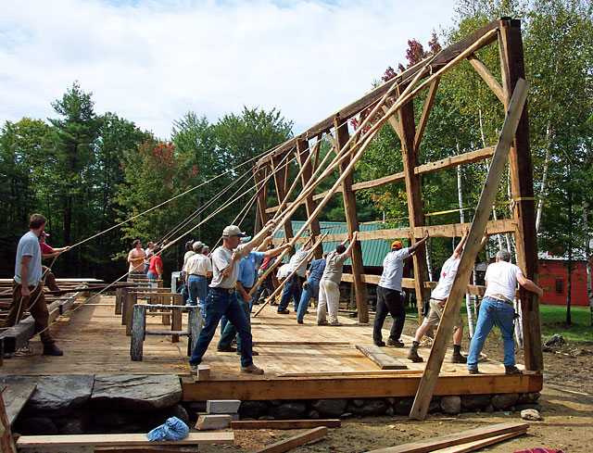  Figure 1 - This sort of barn raising.
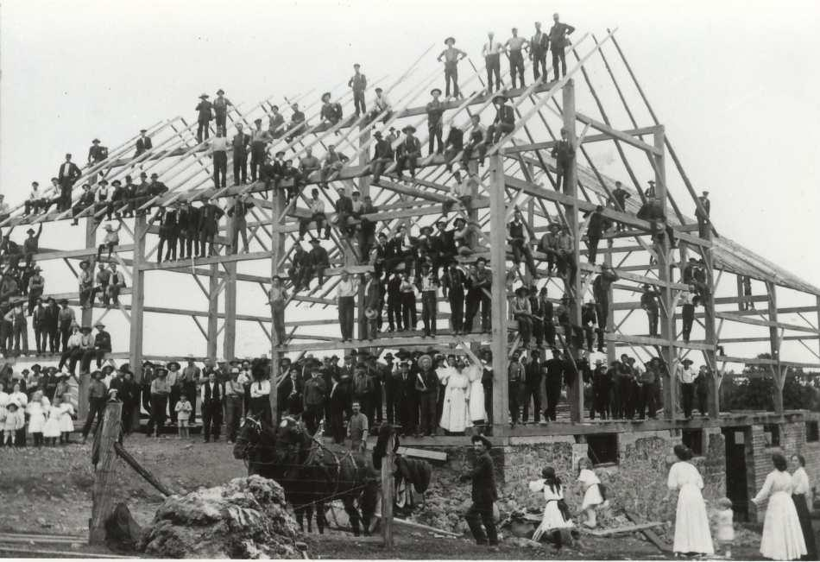
Figure 2 - Or this sort.
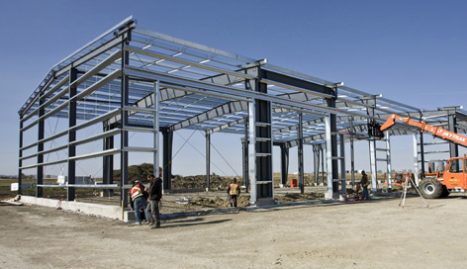
Figure 3 - But NOT this sort.
READINGS
The readings are the foundation of the seminar. They should be completed well in advance of the session during which they are discussed. This gives ample time for consideration of their content. Thoughtful, multi-day reflection on the content of the readings is essential to successful discussions. It is useful to write out, ahead of time, comments that are built upon the readings.

SUMMER READINGS
Introduction and premise:
De Young, R. & T. Princen (2026) Localization Seminar Syllabus. [This document].
Front Matter: Preface and Introduction (pp. vii-xxvi).
Complete the summer assignment detailed below.

BLAME NO ONE
SEPTEMBER 2 – DRIVERS OF LOCALIZATION – RESOURCE DESCENT
Drivers of Localization – Introduction (pp. 2-4)
Chapter 1 The End of Fossil Fuels M. King Hubbert
Morgan, T. (2026) Synopsis: A Summation of the Thesis. Surplus Energy Economics. Retrieved 8-7-26 from: https://surplusenergyeconomics.wordpress.com/synopsis/
De Young, R. (2014) Some behavioral aspects of energy descent: How a biophysical psychology might help people transition through the lean times ahead, Frontiers in Psychology, 5, 1255.
SEPTEMBER 9 – DRIVERS OF LOCALIZATION – CONSUMPTION
Princen, Maniates, Conca (2002) “Confronting Consumption.” In Confronting Consumption. Cambridge, MA: MIT Press. (pp. 1-20).
Monbiot, G. (2015) Consume more, conserve more: Sorry, but we just can’t do both, Guardian, 24 Nov.
Case: Kolbert, E. (2008) “2000 watt society,” pp. 74-77 in “The island in the wind,” The New Yorker.

SEPTEMBER 16 – SOME PROJECTS THAT EMERGED FROM SEMINAR (Readings are from Master’s Projects)
Barr, K. (2022) Farm Stops: A New Way to Enhance Local and Regional Food Systems. (https://issuu.com/katbarr123/docs/farm_stop_report)
Barr, K. (2022) How to Start a Farm Stop: A Pattern Language for Local Food System. (https://localizationpapers.org/wp-content/documents/Barr,%20K.%20(2022)%20How%20to%20Start%20a%20Farm%20Stop.pdf)
Antal, T., B. Frohlich & J. Miller (2022) A framework for strengthening resilience networks in Ypsilanti, Michigan (https://localizationpapers.org/wp-content/documents/Taylor%20et%20al.%20%20Ypsilanti%20Resilience%20Networks%20-%20Integrated%20Research%20Seminar%20(April%202022).pdf)

EXPECT NO HELP

SEPTEMBER 23 – DRIVERS OF LOCALIZATION – COLLAPSE
Scott, J. (2017). “Fragility of the Early State: Collapse as Disassembly.” In Against the Grain: A Deep History of the Earliest States. New Haven: Yale University Press. (read pp. 183-202, 209-218, skim the rest).
Chapter 3 The Inevitability of Transition Joseph A. Tainter
Case: Prologue: La Canicule, in Stone, The City and the Coming Climate, 1-15.

SEPTEMBER 30 – DRIVERS OF LOCALIZATION – BEYOND COLLAPSE
Read, R. & S. Alexander (2019). Chapter 17 – The beginning is near. In This civilization is finished: Conversations on the end of empire and what lies beyond. (pp. 75-79). Simplicity Institute: Melbourne, Australia.
Norberg-Hodge, H. (2019). Postscriptum. In R. Read & S. Alexander, This civilization is finished: Conversations on the end of empire and what lies beyond. (pp. 80-85). Simplicity Institute: Melbourne, Australia.
Greer, J. M. (2012). Progress vs. apocalypse. In T. Butler, D. Lerch & G. Wuerthner [Eds.] The Energy Reader: Overdevelopment and the Delusion of Endless Growth. (pp. 95-101) Sausalito, CA: The Foundation for Deep Ecology.
Case: Box (Planful Shrinkage) (pp. 60) [Also read expanded case by same name on Canvas webpage]

DO SOMETHING

OCTOBER 7 – LOCALIZATION IN PRACTICE
Localization in Practice – Introduction (pp. 56-58)
Chapter 5 An Arc of Scenarios Rob Hopkins
Chapter 6 Inhabiting Place Robert L. Thayer
Brooks, D. (2018). The Localist Revolution, New York Times (19 July 2018).
Case: “Ancient Italian Town Has Wind at Its Back,” Elisabeth Rosenthal, September 28, 2010

OCTOBER 14 – LOCALIZATION IN PRACTICE (continued)
Chapter 7 Locally Owned Business Michael Shuman
Alexander, Ussher (2012). The voluntary simplicity movement, J. of Consumer Culture, 12, 66-86
Brooks, D. (2019). A Nation of Weavers, New York Times (18 Feb 2019).
Case: Box (Localizing Finance) (P. 86)
Case: “How a Bakery Survives the Pandemic Apocalypse,” New York Times, 19 Apr 2020.

OCTOBER 21 – LOCALIZATION IN PRACTICE (continued)
Chapter 9 Civic Agriculture Thomas A. Lyson
Chapter 10 A Whole New Way of Life Karen Litfin
Irwin, D. et al. (2016). Transition Design Monograph (Final version – 15 March 2016).
Case: Box (Erie Canal) (pp. 110)
Case: Box (Belo Horizonte) (pp. 118)

OCTOBER 28 – PHILOSOPHIES OF LOCALIZATION
Philosophies of Localization – Introduction (pp. 142-143)
Chapter 11 The Decentralist Tradition Kirkpatrick Sale
Chapter 12 Technology at a Human Scale Ernst F. Schumacher
Case: “Revived paper Mill Brings a Town Back with It.” New York Times, 2008.
Case: “When rich New Yorkers fled, these workers kept the city running,” New York Times, 16 Jun 2020.

NOVEMBER 4 – PHILOSOPHIES OF LOCALIZATION (continued)
Chapter 13 Provincialism Josiah Royce
Chapter 14 Local Enterprise Wendell Berry
Chapter 15 Conserving Communities Wendell Berry
Case: Box (Breaking the Fossil Fuel Habit) (pp. 14)
Case: “In a City in Italy, Schoolchildren Walk Where Once They Rode,” New York Times, 27 Mar 2009.

NOVEMBER 11 – BRINGING OUT THE BEST IN PEOPLE
Bringing Out the Best in people – Introduction (pp. 208-211)
Chapter 16 Abundance and Fulfillment Sharon Astyk
Chapter 17 Motives for Living Lightly Raymond De Young
Chapter 18 Enabling the Best in People Rachel Kaplan & Stephen Kaplan
Case: Box (Work less) (pp. 209-210)
Case: “Are Bad Times Healthy?” New York Times, 7 October 2008.
Case: “Yes, there is panic, but I am embracing a slower life.” The Washington Post, 23 March 2020.

NOVEMBER 18 – APPROPRIATE GOVERNANCE
Appropriate Governance – Introduction (pp. 242)
Chapter 20 Towards the Regional Gar Alperovitz
Chapter 21 Global Problems, Localist Solutions David J. Hess
Kreitner, R. (2020) A More Perfect Kind of Union? New York Times, 24 April 2020.
Case: Box (Energy islands) (pp. 272)
Case: Kolbert, E. (2008) “Samsø,” pp. 68-73 in “The island in the wind,” The New Yorker.
Case: “A Land Rush in Wyoming Spurred by Wind Power,” New York Times, 28 Nov 2008.

NOVEMBER 25 – THANKSGIVING RECESS

DECEMBER 2 – TOOLS FOR TRANSITION
Tools for Transition – Introduction (pp. 284-285)
Chapter 22 Adaptive Muddling Raymond De Young & Stephen Kaplan
Chapter 23 Promoting a Partnership Society Lester W. Milbrath
Case: Box (Corn to Veggies) (pp. 196)
Case: “An effort to bury a throwaway culture one repair at a time,” Amsterdam J., McGrane (5-8-12).

DECEMBER 9 – PRINCIPLES FOR A RESILIENT TRANSITION
Chapter 24 Tools for the Transition Donella Meadows, Randers & Dennis Meadows
Chapter 25 Downshift/Upshift: Our Choice Raymond De Young & Thomas Princen
Case: Box (The Potato) (pp. 338)

LEARNING OBJECTIVES
The seminar’s objective is to develop a plausible positive response to the reality of an energy descent on a people-rich, resource-poor planet. It does not take a doom and gloom outlook, nor employ the ultimately futile coping strategies of avoidance, denial, or wishful thinking. It pointedly, does not take the business-as-usual, efficiency-driven, greener-and-cleaner technology and policy perspective so comforting and common among environmentalists. It seeks ways to intervene that can hasten the goal of positive localization.
The University's 10th president said a public university "has a fundamental responsibility to be critical of society's current arrangements and to entertain, construct and test alternative visions." That is a radical and exhilarating thought. It is one that we instructors find is mostly honored in the breach. This seminar, nevertheless, accepts this responsibility. It is critical (in a constructive sense) and entertains an alternative vision to the prevailing one that has us dominating ecosystems, and people alike. The seminar will:
- Develop principles, guidelines, and rules-of-thumb for the urgent transition from a resource-intensive, growth-oriented society to a resilient, localized, low-input society.
- Apply insights gained to specific instances of localization.
- Develop the competence and confidence to publicly discuss the premise and practices of localization, and collaborate with community officials and citizens in promoting positive localization.
COMMENT ON THE READINGS
Readings can be found in the textbook (The Localization Reader) or on Canvas. The first, and vital, assignment is to read thoroughly this syllabus, becoming familiar with all its many details.
Prior completion of all readings are required; the seminar functions only when everyone has the same baseline knowledge, accumulated over the semester. Most readings are in the textbook. The goal is not to accumulate many facts. It is not to memorize. Rather, it is to identify key ideas, concepts, biophysical, psychological, and social contexts, and to generate “Do Something” statements related to localization. To facilitate discussion, students should prepare comments and questions and do so before each class. Consider the following strategy:
- Approach the readings as an exploration, an active process of making sense of the piece. One resource that aids this process is Fu (2006). Active reading revisited (available on Canvas).
- Most of the authors were not part of a localization seminar. They would likely frame their piece differently had they been in such a seminar. It will often be useful to reinterpret their work.
- As you read, take notes of your own reactions, especially surprises or passages that contradict your previous understanding (or another reading). Share such notes in discussions.
- Approach the readings, your interpretation, and/or reframing of them, and your note taking from a positive and generative perspective. The seminar seeks to jointly build a pragmatic response to the underexplored biophysical reality of limits. Its purpose it not to criticize each reading for its faults, limitations, sources, etc. (what is otherwise the norm in academic seminars). The purpose is to build upon their ideas and combine them with the works of other authors.
- Note that some of the readings are older (in both the textbook and syllabus). This is intentional. White (2012) has an interesting perspective on this in her review of the text; “…playing that favourite parlour game where you get to invite anyone, unbounded by time or space, to a dinner party” (this review is available on Canvas).
CASES – Human societies have long been organized locally. Recently, cheap and concentrated energy, new technologies, and communications have altered the scale of our settlements and shifted organization to the national and international levels. Examples of localization are hard to come by, as opposed to examples of “the local” which has become an overused notion. Cases can be useful examples; they demonstrate how to provide for basic needs in a durable and resilient manner. Within the readings listed above, there are cases to help us imagine what the transition could be like. Brief texts of these cases are in The Localization Reader and on Canvas with other cases listed below (along with their URL). More examples regularly emerge in the media and on the Resilience.org website.
WRITTEN WORK
Well-written and very carefully edited work is expected. Unless directed, submit written work to tprincen@umich.edu and rdeyoung@umich.edu using “Localization – [deliverable name]” as a subject line. Statements, book reports, and other written assignments should be formatted single-spacing. At a minimum, always:
- Number all pages (and perhaps number all lines in drafts)
- Always include your name, date, email address, and assignment topic
- Edit very carefully (poorly written work will be returned unread):
  - Clearly and logically organized with headings and, as appropriate, subheadings;
  - Transitions from section to section and from paragraph to paragraph are clear; and
  - Language is concise and free of typos, grammatical errors, and misspellings. The reader should contend only with ideas and arguments, not with problems of exposition.
Writing assistance – The instructors assume, and highly recommend, that all students take advantage of the services of the Sweetland Writing Center on campus (1111-1148 Angell Hall; 764-0429). In fact, those with poorly written papers will be referred to the Center and required to submit additional drafts.
TECHNOLOGY AND AI
This course aims to develop strong thinking and conversational skills around the topic of the process of localization. During our discussions, the process of “barn building” requires our full, unmediated attention. Therefore:
- Do not use any electronic device during the seminar (e.g., laptop, tablet, phone).
- Do not use AI to complete any seminar assignment.
EVALUATION
Evaluations will involve a combination of numeric and qualitative assessments. The numeric evaluation will be graded out of 100 possible points and includes the items below. Final grades will be based on numeric and qualitative assessments.
- Weekly preparation, summer prep, and participation, including consistent attendance (25 pts)
- Weekly written statements (25 pts)
- Book report (20 pts)
- Term project (30 pts)
ASSIGNMENTS
The assignments all assume that the premise and intention of the seminar have been fully accepted, even if only for the duration of the term. Use an exploratory yet affirmative approach in all discussions and writings. Discussions and deliverables should not debate the premise nor criticize the authors, point out their faults, explore their limitations, etc. Our goal is to build upon their insights. It will prove necessary periodically to remind ourselves about the seminar’s premise and intention, and to correct our own and other’s misperceptions and misdirection.
- PREPARATION AND PARTICIPATION – Thorough preparation of readings and diligent weekly and term writings are essential to the success of the seminar. In-class activities are the core of the course, where active listening is as important as speaking. Attendance at all class sessions is required. There is no substitute for in-class discussions. Since the seminar is an integrative exercise, presenting one’s views is essential to its success, but so is active, empathetic, and mindful listening and processing.
- SUMMER ASSIGNMENT PRIOR TO FIRST SEMINAR SESSION – Regularly review the website Resilience.org looking for articles relevant to localization. Select one article and prepare a one-paragraph synopsis, then prepare a short paragraph or two with your response to the piece given the premise of this seminar; be prepared to report out to the class.
Deliverables – submit to tprincen@umich.edu and rdeyoung@umich.edu using “Localization – Resilience article” as a subject line by Monday, August 31, 2026. Make a short (5 minute) presentation to class.
- WEEKLY “DO SOMETHING” STATEMENT – THIS ASSIGNMENT STARTS THE FIRST SESSION (Wednesday 9-2-26).
The readings are selected to stimulate thought about localization. No one reading or combination of readings says definitively what localization is, yet each may offer a different perspective or frame for understanding localization. However, the seminar is not a theoretical or academic exercise. The intention is to move beyond auditing and critiquing the past or explaining how we have come to be at the start of a very dramatic and steep downshift. Rather, the intent is to figure out what to do next.
Note: “Do Something” is in the context of the Localization class maxim (Blame no one, Expect no help, Do something) which will be elaborated on during class lectures along with the term “Barn Building” and the notion of collective, constructive, mutually supportive idea generation, one of the course’s contributions to decolonizing academic practice.
Creating a “Do Something” Statement – Write a few carefully crafted sentences based on one (or more) of the week’s readings that answer the advice given in the class maxim: Blame no one, Expect no help, Do something. Do not summarize or criticize the readings. Do not write more than a few sentences (clarity-of-thought, not length, is the goal).
Suggest an action that an individual, a group, an organization, an agency, or a government (local, provincial, national, or international) could take that might contribute to positive localization. Ideally, it should be an action that YOU could take. Do, however, explicit about the actor(s) for whom you are writing.
The action suggested should follow logically from the readings, from its argument or its story or, say, its ethics or passion. The action can be tiny or big, highly specific to a time and place or broadly general. However, it clearly should follow from the readings.
DELIVERABLE – Do the following weekly BEFORE and DURING the seminar:
- Post the text of your “Do Something” action via Canvas under the appropriate week in "Assignment/'Do Something' statements (2026)" at least 24 hours before class starts (by Tues 5:30 pm)
- Print out a hard copy of your statement and bring it to the seminar for posting.
- At the very start of the seminar (5:30 pm) POST your statement on the wall of the seminar room.
- Immediately after posting, read everyone else's statement. Take notes. (DO NOT wait for the instructors to begin class. Begin on your own at 5:30 pm).
- Pick one “Do Something” posted by a classmate to nominate in class as a “Barn Building” discussion starter. The picked submission need not be the best submission but one that the class can productively work on together to build up.
- Turn in the hard copy of your submission with your name on it at the end of class.
OPTIONAL: You can read class members’ submissions in the 24-hour period prior to class time.
- BOOK REPORT – Each student reads an entire book (or a book’s worth of related articles) on localization (or transition, decentralization, downshift), searching actively for insights beyond those obtained in course readings and discussion.
Details: See the separate handout for details on this assignment.
- TERM PROJECT – STORY ASSIGNMENT: Write a story, beginning in class the first day of class, centering on a theme of this course and using our premise (not some other class or other premises). That is, focus on localization, transition, resource descent, systemic reorganization, decentralization, anti-consumerism, place-based living, and/or sufficiency. Develop the story on a daily or near-daily basis throughout the semester.
The story can be fiction or non-fiction, historical or futuristic, journalistic or novelistic. It can reach deep into the past or far into the future (or both) or dwell on the current historical moment. It can be set on a mountain or in a valley, on a river or an island, in a rural community, village or city. It can be in a house or neighborhood, a farm or factory, a tent or college. Wherever it is set, whoever the characters are, it is, to stress, about the larger current societal shift this course calls localization. It accepts the course premise. It is not a critique but rather a “barn building” exercise building a vision of positive localization.
Further details and elements of storytelling will be developed in class as will details of the deliverable.
Note: There are no literary ambitions in this assignment. There are, however, ambitions for useful storytelling (assuming many of us are overwhelmed with unhelpful, distracting, manipulative, aggrandizing storytelling) given the premises and scenarios of this course, not to mention social tumult and biophysical constraint.

